Requirement Analysis

Group ICT1.K62.20201-09

* Trần Hải Sơn - 20176861
* …

# Use case diagram

## General use case diagram

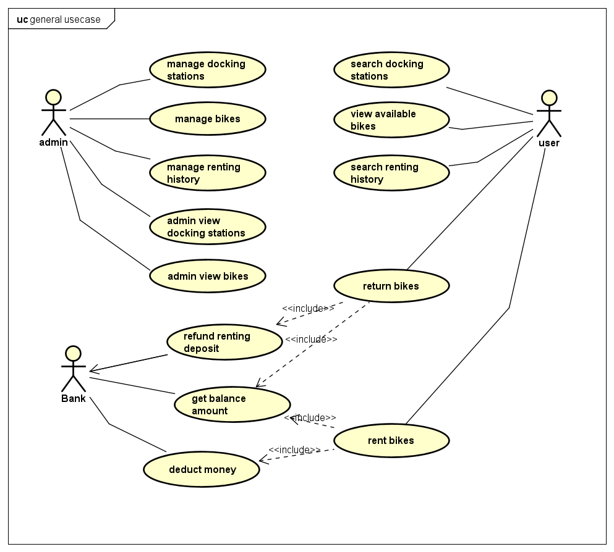

## Use case diagram for “Rent bikes”

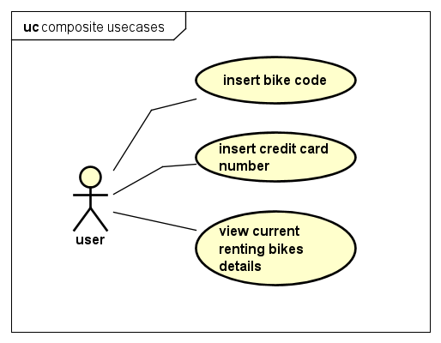

# Use case specification

## Use case “Insert **credit card**”

|  |  |  |  |
| --- | --- | --- | --- |
| **Use case code** | UC001 | **Use case name** | Insert credit card |
| **Actor** | User | | |
| **Precondition** | User must be in docking station before renting bike | | |
| **Main flow of event**  **(success)** | |  |  |  | | --- | --- | --- | | No | Doer | Action | | 1. | User | Press "Rent" button. | | 2. | System | Display dialog to enter card number. | | 3. | User | Enter card number (description below *). | | 4. | User | Request for bike (press confirm button). | | 5. | System | Check if card number is valid or not. | | 6. | System | Check if credit card is available or not. | | 7. | System | Check if credit card has enough money to perform transaction or not. | | 8. | System | Prompt user and move to another screen to show state when renting bike. | | | |
| **Alternative flow of event** | |  |  |  | | --- | --- | --- | | No | Doer | Action | | 5a. | System | Error: card number is invalid. | | 6a. | System | Error: credit card is being used to rent bike. | | 7a. | System | Error: credit card does not have enough money to perform transaction. | | | |

* Bike code requirement.

|  |  |  |  |  |  |
| --- | --- | --- | --- | --- | --- |
| No | Input | Description | Compulsory? | Valid condition | Example |
| 1. | Card number | User must enter credit card to rent bike, 1 credit card is allowed to rent only 1 bike at a time. | Yes | Card number must be same with valid code in the system | 201768612017 |